Purpose
The aim of the Archdiocesan and The Tindall Foundation Allocation Committee is to assist with funding Catholic and community organisations within the Wellington Archdiocese rohe.

The priority is to fund organisations who are working in areas identified as priorities by The Tindall Foundation and aligned with the Archdiocesan goals.

Background
The Tindall Foundation (TTF)
TTF makes an annual grant to the New Zealand Catholic Bishops Conference (NZCBC). The NZCBC is a ‘Faith-based’ Local Donation Manager for TTF. The Tindall Foundation Allocation Committee acts as the NZCBC agent in the Archdiocese of Wellington. See www.tindall.org.nz for more information.

The Archdiocese of Wellington (Archdiocese)
The Archdiocesan region spans the central New Zealand area from a line between Levin and Masterton in the north to the southern boundary from Kaikoura to Westport. There are 21 Parishes and 43 schools, both primary and secondary. There are also central pastoral agencies coordinating services including education, youth and young adult ministry, ministry with Pacific peoples, family life, Catholic Māori, management of funds and social services. There are a number of groups in the Archdiocese, both Catholic and community based, who share common goals in social service, education and charity.

Process
Drawing from the funding base, the Archdiocesan and The Tindall Foundation Allocation Committee allocates resources based on criteria as outlined on the Goals and Priorities information pages. Donations range from $500 to $15,000. Allocations are made annually and applications close Friday 2 October 2026.

Contact
Applications should be made by completing the attached form and emailing it to: tindall@cadw.nz

More information is available on the allocation’s website: https://cadw.nz/tindall

Any questions can be directed by email to tindall@cadw.nz or by phone: 021 221 3944.

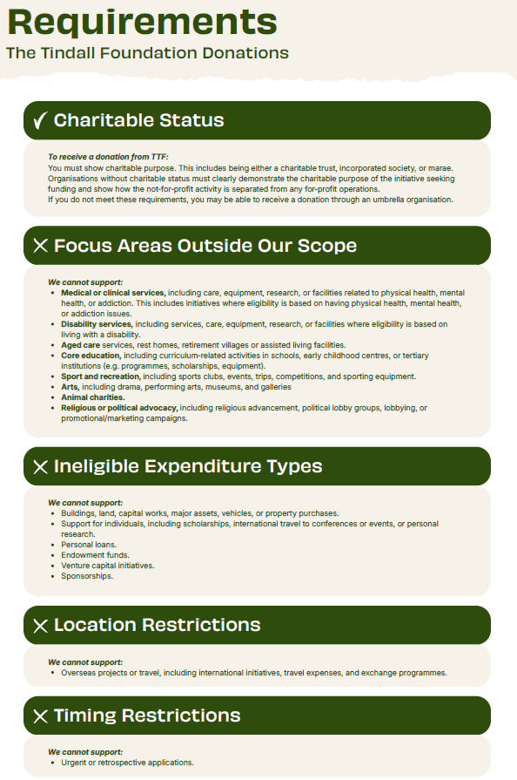
APPLICATION FORM
The Archdiocese of Wellington acts as a Local Donation Manager for The Tindall Foundation, a philanthropic family foundation working throughout Aotearoa to support families, community and the environment. We are what is called a Faith Donation Manager, meaning that we distribute donations on behalf of TTF to projects and initiatives supporting Intergenerational Wellbeing for Aotearoa.

Successful applicants are required to provide an Accountability Report within 12 months, or an interim report if applying again before the completion of your project, followed by a full Accountability Report. Please keep a copy of this application form for your own records. Applications are due by Friday 2 October 2026 to tindall@cadw.nz

Please note that `Environmental` initiatives through `Empowering local communities and young people to protect and restore Aotearoa’s native habitats and species through hands-on conservation, education and mātauranga Māori` requests for funding should go through WWF NZ, as the environmental Local Donation Manager partner, for The Tindall Foundation Local Donation Managers | The Tindall Foundation.

ORGANISATION DETAILS
Organisation Name
Postal address:
Street address:
Contact name:
Contact phone:
Contact email:
Organisation website:

Which of the following categories best describes your organisation’s legal status:
Is your organisation:
☐ Charitable
☐ Non-charitable
☐ Charitable trust – Please provide Charities Commission number:________________
☐ Incorporated society
☐ Company/social enterprise
☐ Government/statutory body
☐ Registered under the Māori Land Court
☐ Catholic parish
☐ Archdiocesan agency
☐ Catholic organisation
☐ Other __________________

Organisation’s bank account:
Bank name:
Organisation’s registered bank account name:
Bank account number (digits only):

About your organisation:
What is the main purpose of your organisation, and what are your key activities?
Who is your organisation primarily aiming to help or support?
Please include a copy of your most recent statement of finance or audited accounts or tell us if these are available on the charities services website Y/N

Kaupapa Māori:
Are you a Kaupapa Māori organisation? (by Māori for Māori, with over half your decision-makes being Māori) organisation.  If you would like to share further details, please do | Y/N
What areas of delivery do you work in?

Are you a Raranga organisation (weaving a Māori kaupapa through your service/ less than 50% of decision makers being Māori)? | Y/N
How is your organisation supported or endorsed by Māori communities?

The initiative:
What is the title of your initiative?
And when will it start/end

Details of the initiative/project to be funded and area/region you will be working in:
What is the need your project addresses?
Key people, organisations, and networks involved in this project:
Is this a new or existing initiative?
How does your project fit within the goals and priorities?

OUTCOMES
We understand you wish to carry out this initiative/project to make a difference. Please specify up to three defined outcomes you aim to achieve, including numbers of clients and participants, and the indicators you will use to track your progress. We will ask you to report against these outcomes if your application is successful.

Please tell us what you are aiming to achieve through this project:
 | What are you aiming to achieve for participants? | How will you measure your achievements?
1.
2.
3.

At the end of your donation, you will be asked to report back on what you’ve achieved.

BUDGET
Amount applied for: | NZ$
Please note that donations do not include GST and beneficiaries of a donation do not need to account for a donation from The Tindall Foundation in their GST returns to the IRD.

Please complete the budget by entering the expected cost and income items of your project:

Project Budget

Expense description | NZ$
Total

Income sources | Amount NZ$ | Confirmed? | Decision date
Requested from Archdiocesan and The Tindall Foundation Allocation Committee
Total

Have you received government funding for this project in the last three years? If yes, please provide details:
How will this project be funded after the donation has ended?
Do you anticipate any material changes to your current funding and/or expenditure? If yes, please provide details:

Previous and current applications:
Please give dates of previous applications made to the Archdiocese of Wellington Tindall Allocations Committee or other Local Donation Managers:

- ATTACHMENTS
Please attach the following:
- A recent copy of Bank Statement or Bank Deposit Slip
- A copy of your most recent statement of finance/audited accounts/charities services details
- Additional information to support your application, e.g. project plan, detailed budget, other research or evidence.

REFEREES
Please supply details of two referees for your project:
Name
Address:
Phone:
Email

Organisation and Personal Information (Privacy Act 2020 and Unsolicited Electronic Messages Act 2007)
The Archdiocesan and The Tindall Foundation Allocation Committee may collect and store, for a reasonable time, information you provide us in connection with this application.
Organisations and individuals have the right to ask, see and correct personal information we hold about them. Organisations and personal information collected will be held by the Trust for the purposes of administration and assessment of applications and may be shared with other parties in the course of that process or in publishing the results of approved grants.
Please indicate by signing the Declaration that you agree to the Archdiocesan Tindall Allocations Committee using your organisation or personal information for the following purposes:
- For providing Archdiocesan and The Tindall Foundation Allocations Committee information to you or your organisation;
- For research purposes approved by our committee;
- To send you information on behalf of other organisations which is relevant to you or your organisation.
DECLARATION
This declaration and authorisation relate to information in this application and attachments that the Archdiocesan and The Tindall Foundation Allocation Committee may hold about your organisation/group now or in the future.
In making this declaration I declare that:
- this application has been submitted with the full knowledge and agreement of the Management/governance of my organisation/group;
- the information supplied in this application and any attachments is true and factual;
- any grant received will be used for the purpose for which it was approved.
I authorise the Archdiocesan and The Tindall Foundation Allocation Committee to:
- use the information supplied as part of this application and any attachments for the purposes of administration and consideration of this application;
- make any enquiries of any third parties, (which may involve discussing information contained in this application) or undertake audits of our organisation/group in connection with this application;
- advertise or publish the name of our organisation/group and the amount of any grant approved if this application is successful, including disclosure of this information to other funding agencies.
I acknowledge that:
- the decision of the Archdiocesan and The Tindall Foundation Allocation Committee is final and accept that no reason for such a decision may be given.
I agree that:
- the donation made will be used for the purposes specified in this application. If my organisation cannot comply with the conditions of the donation within the specified time, we will advise the and The Tindall Foundation Allocation Committee of the surrounding circumstances to enable a review.
- a narrative and financial report of the use of funds will be provided within 12 months of receiving the donation.

I am authorised to complete this application, and I have read and understood this Declaration and the Privacy Statement:

Authorised Person’s Name:

Signature:

Position in organisation:

Email:

Date of declaration:

